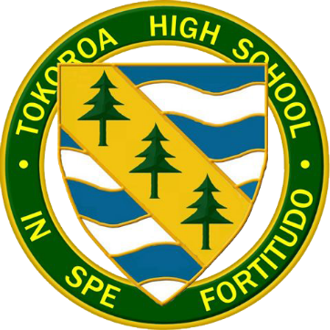
TE ARA HOU
University Pathway Programme
Want to get a degree? Now you can!
In conjunction with the University of Waikato, Tokoroa High School is offering a Year 14 (18 years+) programme designed to transition students into Bachelor studies at tertiary level.

Te Ara Hou is a student focused programme offering:
- ZERO course fees – students will pay no fees for school or university papers – potentially saving $2500
- No entry requirements – students do not have to have University Entrance to enrol
- Flexible programming – allows for part-time employment
- Supportive academic environment at Tokoroa High School
- 30+ University papers to choose from

For more information or to enrol contact:
Latisha Kelly 0800TOKHUB latishak@tokoroahigh.school.nz

